Region in Solid Geometry
# Source: AI Source: Provided by: [Data Path: Persons Table -> ID Column: 1, Name_En Column: Motasem Essam] -> From: [ChatGPT] on [7/25/2026]
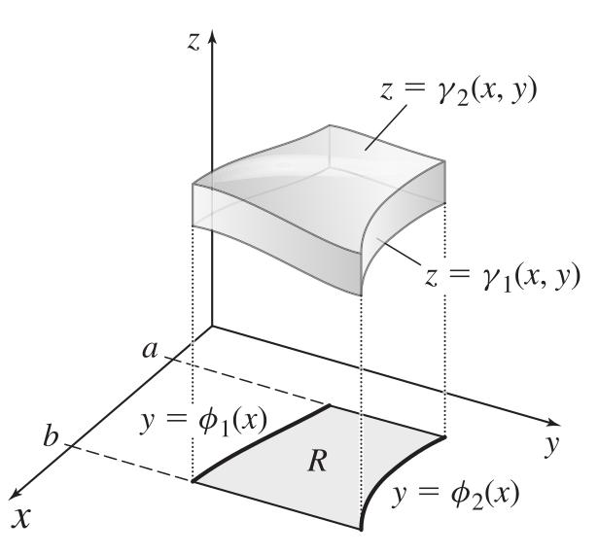
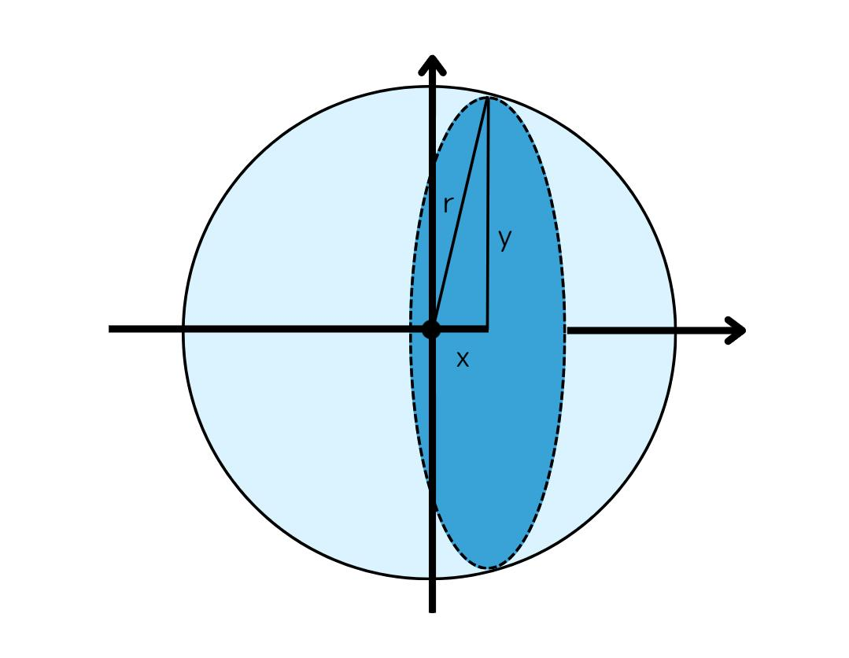
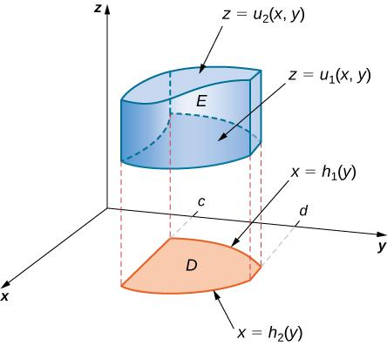

Definition
# Source: AI Source: Provided by: [Data Path: Persons Table -> ID Column: 1, Name_En Column: Motasem Essam] -> From: [ChatGPT] on [7/25/2026]
A region in Solid Geometry is a set of points occupying a portion of three-dimensional space, described by specified geometric boundaries or conditions. A region may include its boundary or exclude it, depending on how it is defined.
A region can be bounded, such as the interior of a cube, or unbounded, such as the set of all points above a plane.

2. Simple Definition
# Source: AI Source: Provided by: [Data Path: Persons Table -> ID Column: 1, Name_En Column: Motasem Essam] -> From: [ChatGPT] on [7/25/2026]
A region is a part of three-dimensional space containing a collection of points.
For example, the interior of a sphere forms a three-dimensional region. If its boundary is included, the region contains both the interior points and the spherical surface.

Key Characteristics
# Source: AI Source: Provided by: [Data Path: Persons Table -> ID Column: 1, Name_En Column: Motasem Essam] -> From: [ChatGPT] on [7/25/2026]
- Three-dimensional setting: A solid region consists of points in three-dimensional space.
- Point set: It is defined by the collection of points satisfying specified conditions.
- Boundary: A region may have a boundary made of faces, curved surfaces, or other geometric sets.
- Volume: A measurable three-dimensional region can have a volume.
- Boundedness: A region may fit inside some finite sphere or extend infinitely.
- Boundary inclusion: Its definition determines whether boundary points belong to the region.
- Geometric description: Regions can be defined using inequalities, equations, or geometric objects.

Types of Regions in Solid Geometry
# Source: AI Source: Provided by: [Data Path: Persons Table -> ID Column: 1, Name_En Column: Motasem Essam] -> From: [ChatGPT] on [7/25/2026]
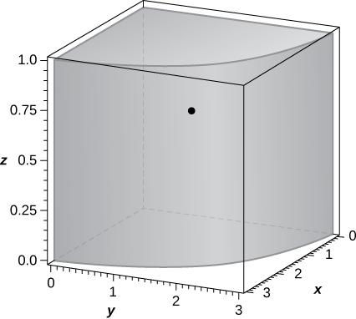

1. Bounded Region
# Source: AI Source: Provided by: [Data Path: Persons Table -> ID Column: 1, Name_En Column: Motasem Essam] -> From: [ChatGPT] on [7/25/2026]
A region contained within a finite distance, so it does not extend infinitely in any direction.
Examples: The interior of a cube, a ball, or a finite cylinder.
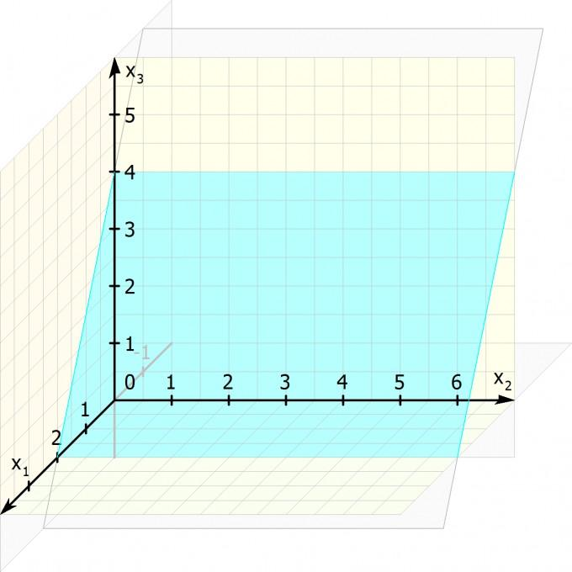

2. Unbounded Region
# Source: AI Source: Provided by: [Data Path: Persons Table -> ID Column: 1, Name_En Column: Motasem Essam] -> From: [ChatGPT] on [7/25/2026]
A region that extends indefinitely in at least one direction.
Example: The half-space consisting of all points above a plane.
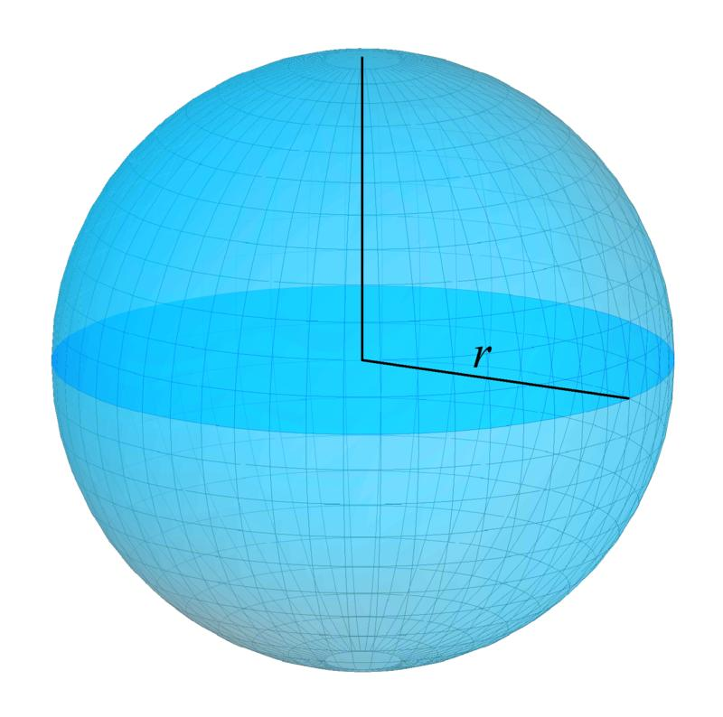

3. Interior Region
# Source: AI Source: Provided by: [Data Path: Persons Table -> ID Column: 1, Name_En Column: Motasem Essam] -> From: [ChatGPT] on [7/25/2026]
The collection of points inside a solid, excluding its boundary.
Example: All points whose distance from a sphere's center is strictly less than its radius.
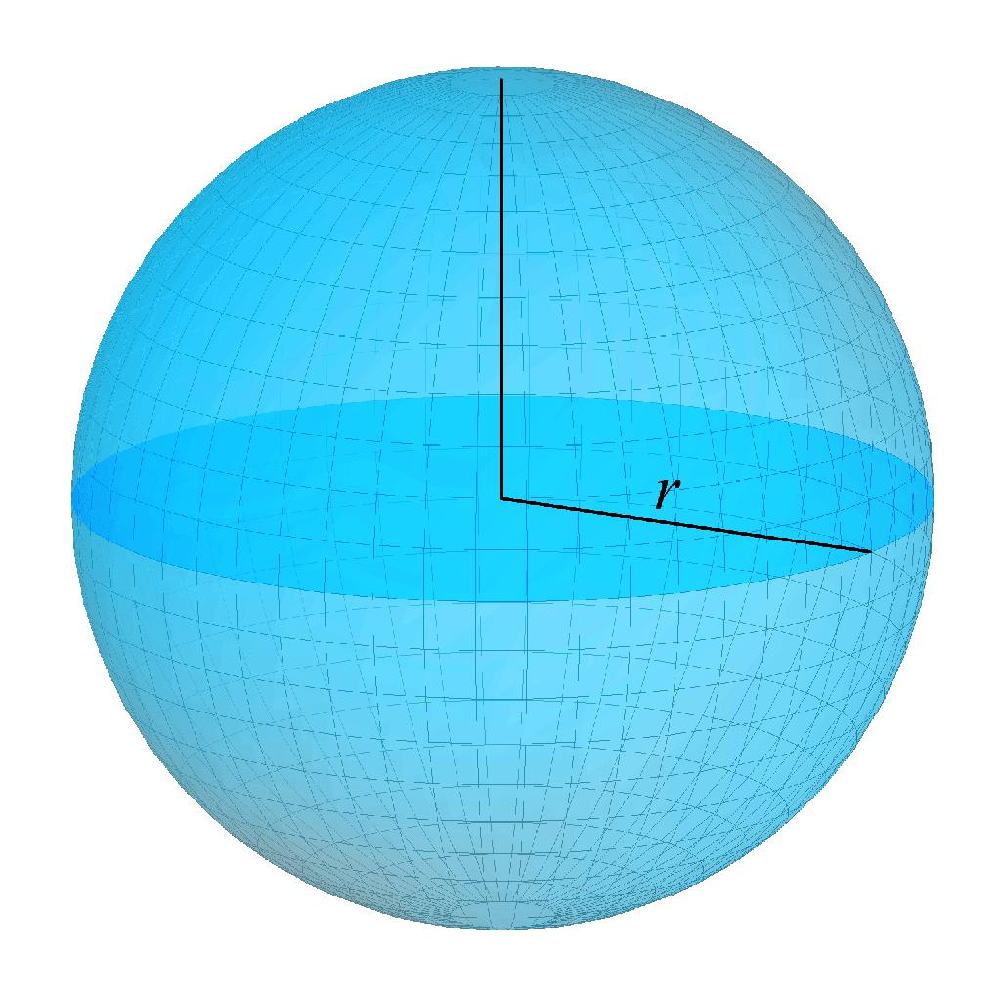

4. Connected and Disconnected Regions
# Source: AI Source: Provided by: [Data Path: Persons Table -> ID Column: 1, Name_En Column: Motasem Essam] -> From: [ChatGPT] on [7/25/2026]
A connected region cannot be separated into two nonempty, disjoint parts that are open relative to the region. A disconnected set can be separated in this way.
Examples: A solid ball is connected; two separate solid balls form a disconnected union when they are apart.

Open and Closed Regions
# Source: AI Source: Provided by: [Data Path: Persons Table -> ID Column: 1, Name_En Column: Motasem Essam] -> From: [ChatGPT] on [7/25/2026]
The distinction between open and closed regions concerns whether boundary points are included. More precisely, open and closed are mathematical properties of sets.
Consider a sphere with center $C=\left(0,0,0\right)$ and radius $r$.

Open ball — boundary excluded
# Source: AI Source: Provided by: [Data Path: Persons Table -> ID Column: 1, Name_En Column: Motasem Essam] -> From: [ChatGPT] on [7/25/2026]
$$x^{2}+y^{2}+z^{2}<r^{2}$$
This contains points strictly inside the sphere, but not points on its surface.

Closed ball — boundary included
# Source: AI Source: Provided by: [Data Path: Persons Table -> ID Column: 1, Name_En Column: Motasem Essam] -> From: [ChatGPT] on [7/25/2026]
$$x^{2}+y^{2}+z^{2}≤r^{2}$$
This contains both interior points and points on the spherical surface.
Note: In three-dimensional Euclidean space, an open ball is open and a closed ball is closed in the standard topological sense.

Mathematical Representation of Regions
# Source: AI Source: Provided by: [Data Path: Persons Table -> ID Column: 1, Name_En Column: Motasem Essam] -> From: [ChatGPT] on [7/25/2026]
A region can be represented using coordinates and equations or inequalities.

1. Spherical Region
# Source: AI Source: Provided by: [Data Path: Persons Table -> ID Column: 1, Name_En Column: Motasem Essam] -> From: [ChatGPT] on [7/25/2026]
For a sphere centered at the origin with radius $r$, the closed ball is
$$\boxed{x^{2}+y^{2}+z^{2}≤r^{2}}$$
Its volume is
$$\boxed{V=\frac{4}{3}πr^{3}}$$

2. Cubical Region
# Source: AI Source: Provided by: [Data Path: Persons Table -> ID Column: 1, Name_En Column: Motasem Essam] -> From: [ChatGPT] on [7/25/2026]
For a cube occupying coordinates from $0$ to $a$ along each axis:
$$\boxed{0≤x,y,z≤a}$$
Its volume is
$$\boxed{V=a^{3}}$$

3. Half-Space Region
# Source: AI Source: Provided by: [Data Path: Persons Table -> ID Column: 1, Name_En Column: Motasem Essam] -> From: [ChatGPT] on [7/25/2026]
The set of points satisfying
$$\boxed{z≥0}$$
is the closed half-space on or above the $xy$-plane. It is unbounded and includes the plane $z=0$.

4. Cylindrical Region
# Source: AI Source: Provided by: [Data Path: Persons Table -> ID Column: 1, Name_En Column: Motasem Essam] -> From: [ChatGPT] on [7/25/2026]
A closed circular cylinder of radius $r$ and height $h$, aligned with the $z$-axis and based at $z=0$, can be described by
$$\boxed{x^{2}+y^{2}≤r^{2}, 0≤z≤h}$$
Its volume is
$$\boxed{V=πr^{2}h}$$

Fundamental Properties

1. Region and Boundary
# Source: AI Source: Provided by: [Data Path: Persons Table -> ID Column: 1, Name_En Column: Motasem Essam] -> From: [ChatGPT] on [7/25/2026]
A region may contain its boundary, exclude it, or be defined in another way. The boundary separates the region's interior from its exterior.

2. Volume
# Source: AI Source: Provided by: [Data Path: Persons Table -> ID Column: 1, Name_En Column: Motasem Essam] -> From: [ChatGPT] on [7/25/2026]
A bounded three-dimensional region with a suitable measurable structure has a volume. Common formulas include:
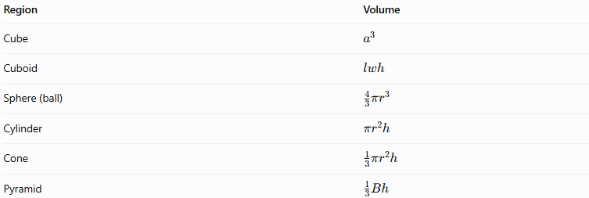
Region | Volume
Cube | $$a^{3}$$
Cuboid | $$lwh$$
Sphere (ball) | $$\frac{43}{π}r^{3}$$
Cylinder | $$πr^{2}h$$
Cone | $$\frac{1}{3}πr^{2}h$$
Pyramid | $$\frac{1}{3}Bh$$
Here, $B$ is the area of the base, and $h$ is the perpendicular height.

3. Union, Intersection, and Difference
# Source: AI Source: Provided by: [Data Path: Persons Table -> ID Column: 1, Name_En Column: Motasem Essam] -> From: [ChatGPT] on [7/25/2026]
Regions can be combined using set operations:
- Union: $A∪B$ contains points belonging to either region.
- Intersection: $A∩B$ contains points shared by both regions.
- Difference: $A∖B$ contains points in $A$ but not in $B$.
These operations are useful for describing composite solids and regions with holes or cutouts.

Region vs. Solid vs. Surface
# Source: AI Source: Provided by: [Data Path: Persons Table -> ID Column: 1, Name_En Column: Motasem Essam] -> From: [ChatGPT] on [7/25/2026]
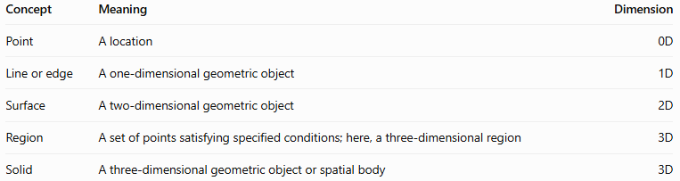
Concept | Meaning | Dimension
Point | A location | 0D
Line or edge | A one-dimensional geometric object | 1D
Surface | A two-dimensional geometric object | 2D
Region | A set of points satisfying specified conditions; here, a three-dimensional region | 3D
Solid | A three-dimensional geometric object or spatial body | 3D
A region emphasizes the collection of points and the conditions defining it. A solid often emphasizes the geometric body itself. In many contexts, the terms solid region and solid are used interchangeably.

Applications
# Source: AI Source: Provided by: [Data Path: Persons Table -> ID Column: 1, Name_En Column: Motasem Essam] -> From: [ChatGPT] on [7/25/2026]
- Geometry: Defining the interior and exterior of solids.
- Calculus: Calculating volume through multiple integrals.
- Computer graphics: Representing occupied space and modeling solid objects.
- Engineering: Defining material regions and component boundaries.
- Physics: Describing spatial domains in which quantities are measured.
- Optimization: Finding maximum or minimum values subject to spatial constraints.

Key Points
# Source: AI Source: Provided by: [Data Path: Persons Table -> ID Column: 1, Name_En Column: Motasem Essam] -> From: [ChatGPT] on [7/25/2026]
- A region is a collection of points satisfying geometric conditions.
- A three-dimensional region occupies a portion of space.
- A region can be bounded or unbounded.
- Boundary points may be included or excluded.
- Equations and inequalities can define regions precisely.
- Volume measures the three-dimensional extent of a suitable region.
- A surface forms a boundary, while a region describes a set of points in space.

Conclusion
# Source: AI Source: Provided by: [Data Path: Persons Table -> ID Column: 1, Name_En Column: Motasem Essam] -> From: [ChatGPT] on [7/25/2026]
A region in Solid Geometry is a collection of points occupying a specified portion of three-dimensional space. Regions can be described by geometric boundaries, coordinate equations, or inequalities. Understanding boundedness, boundaries, interior points, and volume helps distinguish different spatial sets and provides a foundation for studying solid geometry, calculus, engineering, and three-dimensional modeling.

